Bill Payment
Objective
Submission of monthly payment to the accounts payable department.
Responsibility Definition
This payment must be executed by the area Manager.
Required Items
Adobe Acrobat Reader PRO – Approved by Contoso.
Service provider invoice (Nota Fiscal).
- Payment slip (Boleto) or payment details from the service provider.
- PO (Purchase Order) details to be attached to the document.
Step by Step
- Open the Nota Fiscal and payment slip (Boleto) files with Adobe Acrobat Reader PRO.
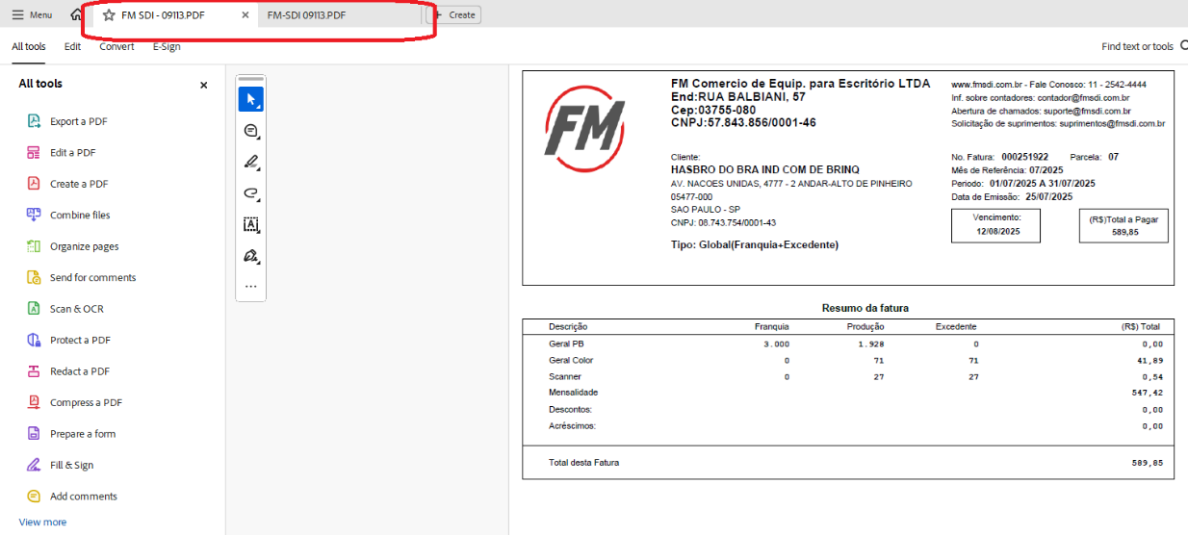
- Use the "Combine Files" button, click "Add open files" and confirm that both files are selected.
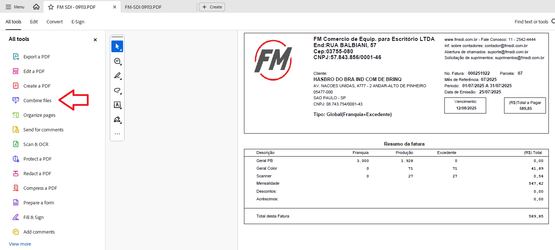
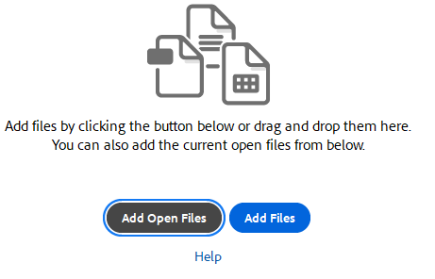
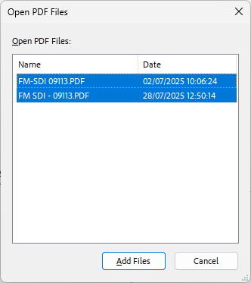
- Remove all extra pages and keep only the service Nota Fiscal and the payment slip (Boleto).
- Use the text tool to insert the PO for the provided service on one of the pages:
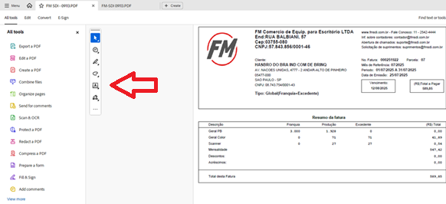
- Save the document.
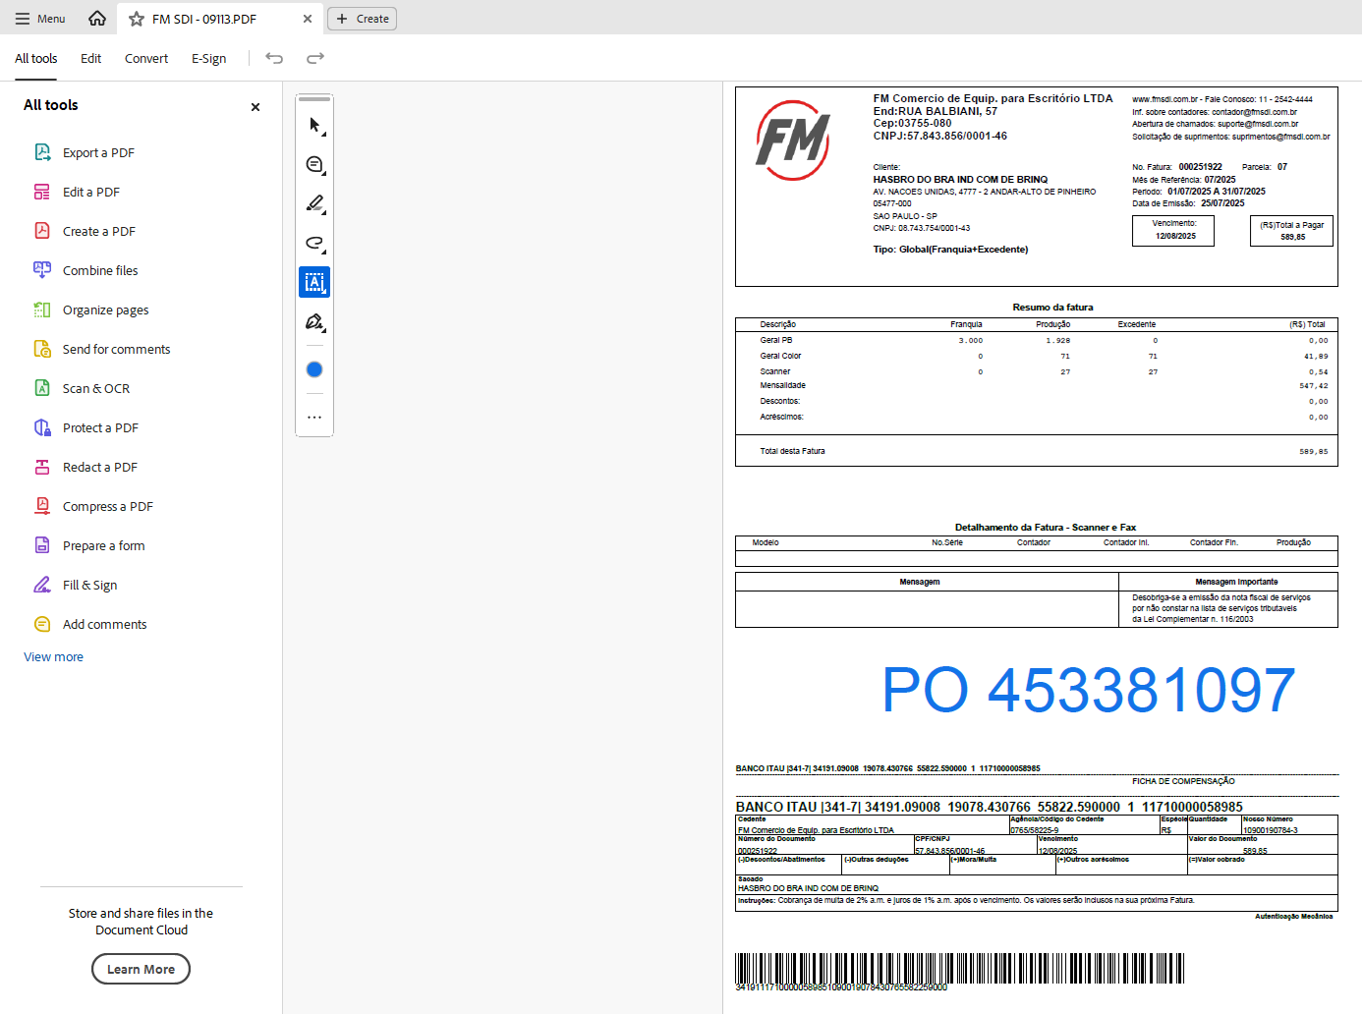
- Without a subject, body text, or signature, send an email to apbrpo@erp.contoso.com and attach the saved file.
Note: Payment is due by the 20th of the month.

Version History
Author | Version | Date | Change Description
IT Team | 1.0 | 28/07/2025 | Creation
Lucas Souza | — | Jun/2026 | Document standardization

